Directions: The goal of the following problems is to help challenge and deepen your understanding of the current topic. Don’t assume that you will know how to answer each and every question. You will work with at least two other students in the class to try and find solutions and write arguments for each of the following questions. Be sure that you question your classmates’ reasoning. If you don’t understand how they are getting something you should ASK THEM TO EXPLAIN! Being able to defend your reasoning is important and so you are actually helping them by asking them to explain.

Challenge Questions
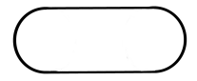
- A farmer is going to use fence to make a pen shaped like cutting a circle in half and inserting a rectangle (like in the picture below).

If the pen is to have an area of , how should he make the pen to minimize the amount of fence needed? Find all dimensions of the pen and sketch a picture of it.

- For each , a triangle is formed with vertices and where is the function given below. What is the value of x which results in the triangle of largest area? What is this largest area?

- A rectangular box, without a top, is to be made by cutting squares out of corners of a sheet of carboard and folding up the sides (like in the diagram below). Find the maximum volume of such a box from a sheet measuring 4 meters by 4 meters.

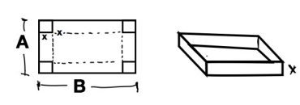
- A rectangular box, without a top, is to be made by cutting squares out of corners of a sheet of carboard and folding up the sides (like in the diagram below). Show that the maximum volume of such a box from a sheet measuring A meters by B meters occurs when the squares cut out have side lengths

- A cone-shaped drinking cup is made from a cicular piece of paper of radius R by cutting out a sector and joining the edges of CA and CB. Find the angle that is needed in order to maximize the capacity of such a cup.
